The Schneider Prize for Technology Innovation
  - Presented by MRG Laboratories
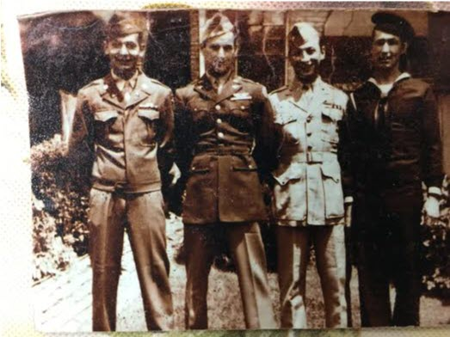
(L-R) Frank Schneider, US Army; Dr. Tony Schneider, US Army Air Corps; Dr. Henry Schneider, US Marines; Edward A. Schneider, Jr, US Navy
The Schneider Prize for Technology Innovation was founded in 2017 to honor the accomplishments of the Schneider family of York County, PA. Four brothers from York enlisted in the four branches of the military during World War II, while their sisters and parents served at home. The brothers returned to become scientists, engineers and civil servants, making their mark on our community. This prize honors their family’s achievements in our community and will be awarded to a Hack that results in ideas and innovations for communicating and educating about specific technology.
In 2018, the prize was offered to the developer or team of developers that could improve upon the use of our current Grease Thief® technology. The winning team shared the $1000 prize for their coding design and solution for creation of a criteria data set that generated actions based on lubricant color changes. This led to our current patented Grease Thief Colorimeter that customers can use on-site to analyze and quantify color changes in grease.
In 2021, the Schneider Prize addressed using a Raspberry Pi to develop a program to connect and collect data from multiple devices (such as sensors, scales, barcode scanners, any student designed device, etc) to be uploaded to a website via a HTTP request. The winning entry was able to demonstrate a design linked to their previous work as an intern in the York College Manufacturing Fellowship grant project.
The 2026 Schneider Prize for Technology Innovation Challenge:
Create an efficient way for the laboratory to take information from hand-written or typed-and-printed sample labels and convert that to a digital format which can be uploaded to our database.
Prizes to be split amongst all group members
1st – $1,000
2nd (If Applicable) – $500

Best of luck to all Hackathon Participants!



Join our Discord to stay up to date on project changes and ask questions to the MRG Staff

View our GitHub Repo for full challenge details, project template, and examples.

